Assignment-8

8.1:

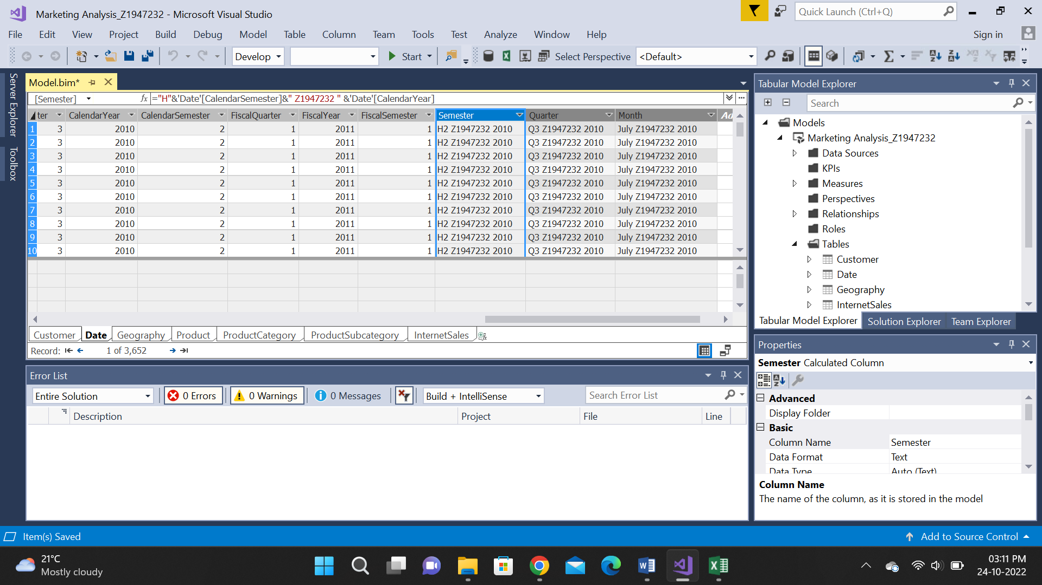

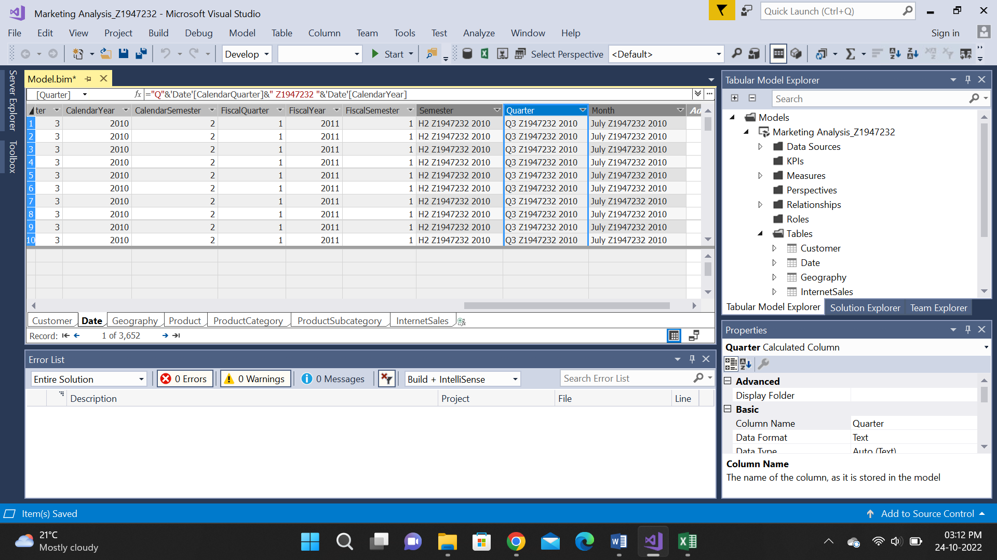

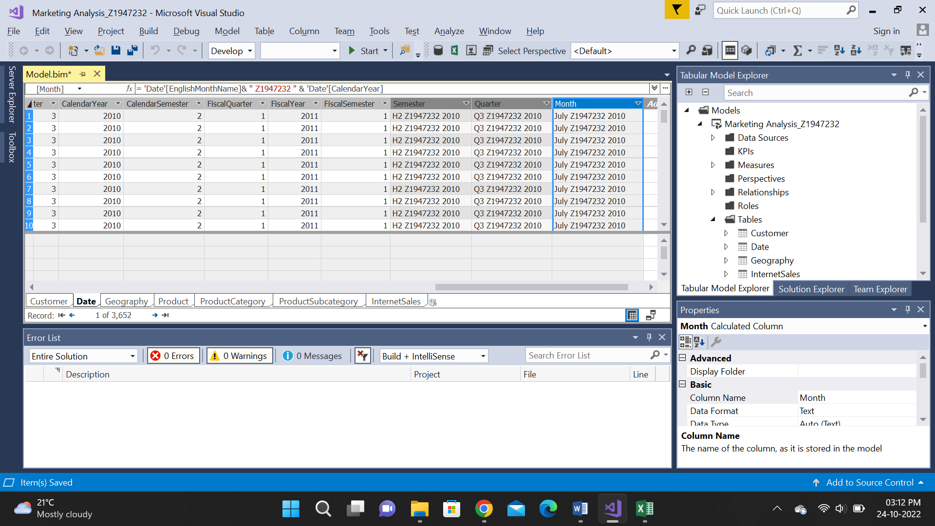

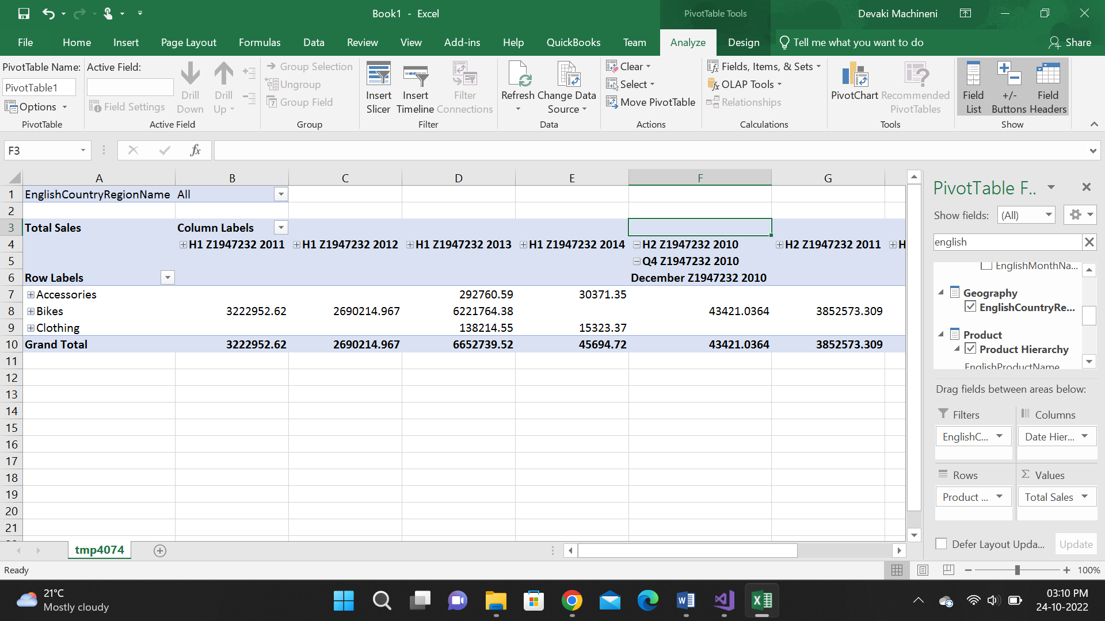

Here I have created a separate hierarchy named date hierarchy with the semester, Quarter, and Month columns.

8.2: sort of months-

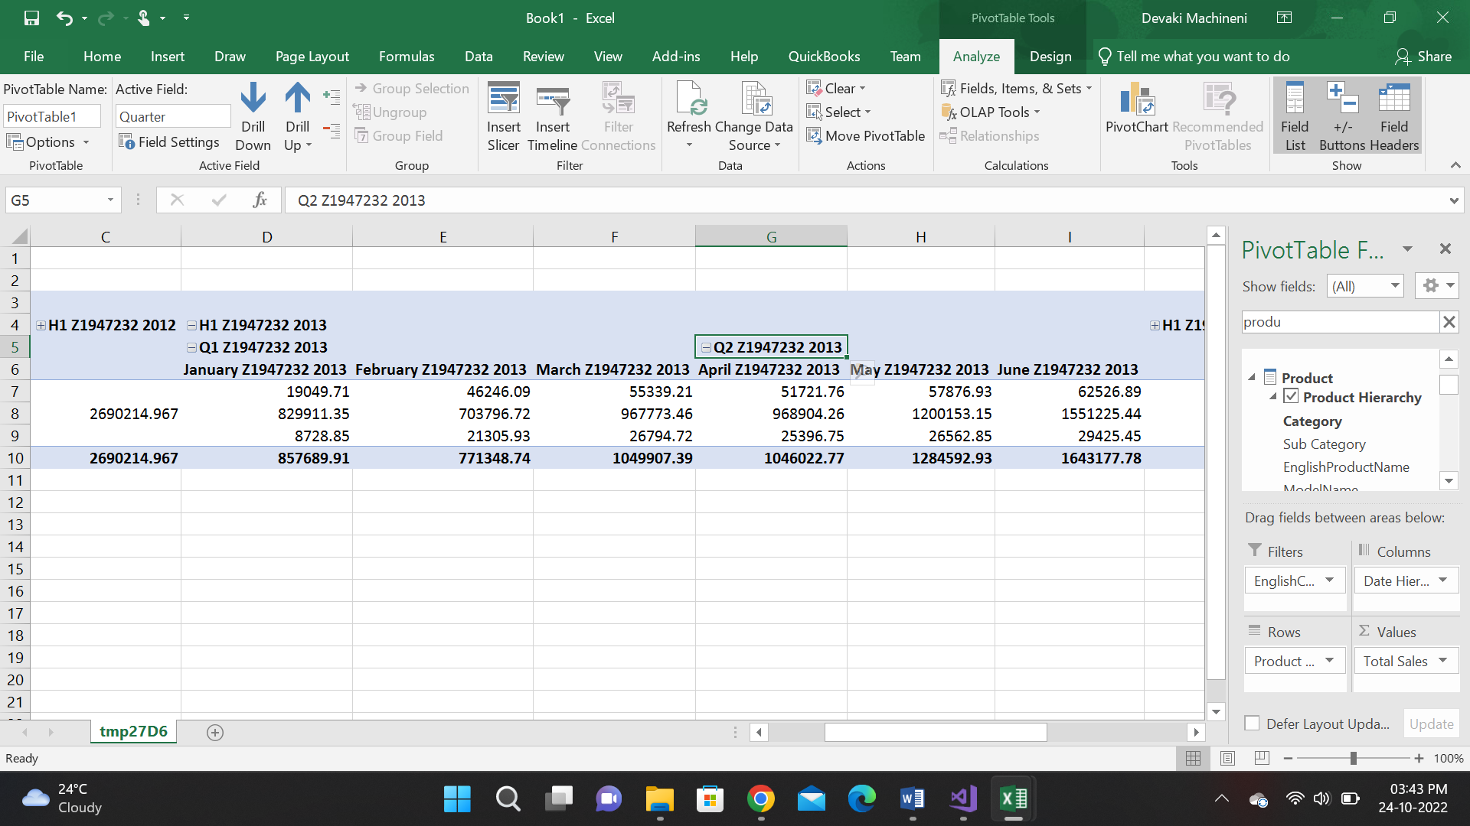

8.3

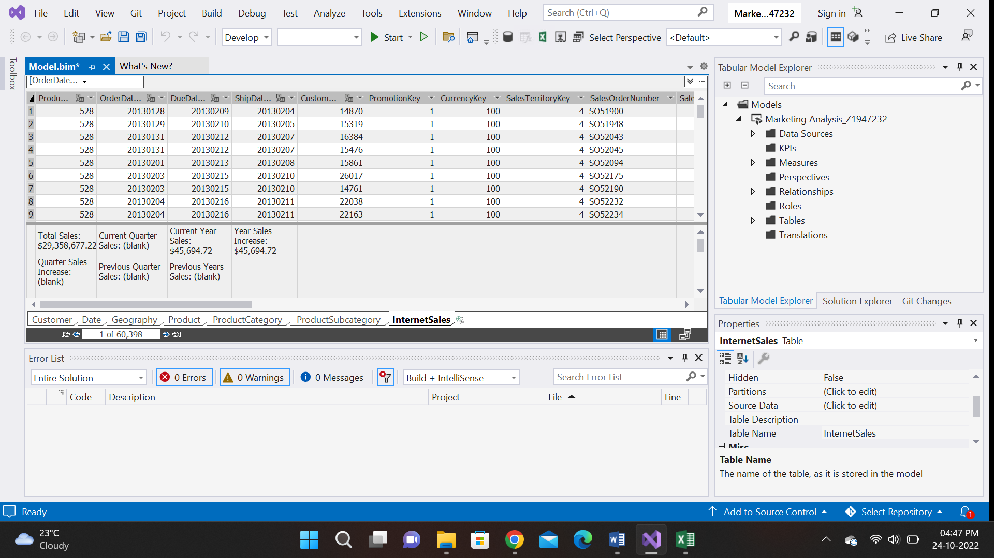

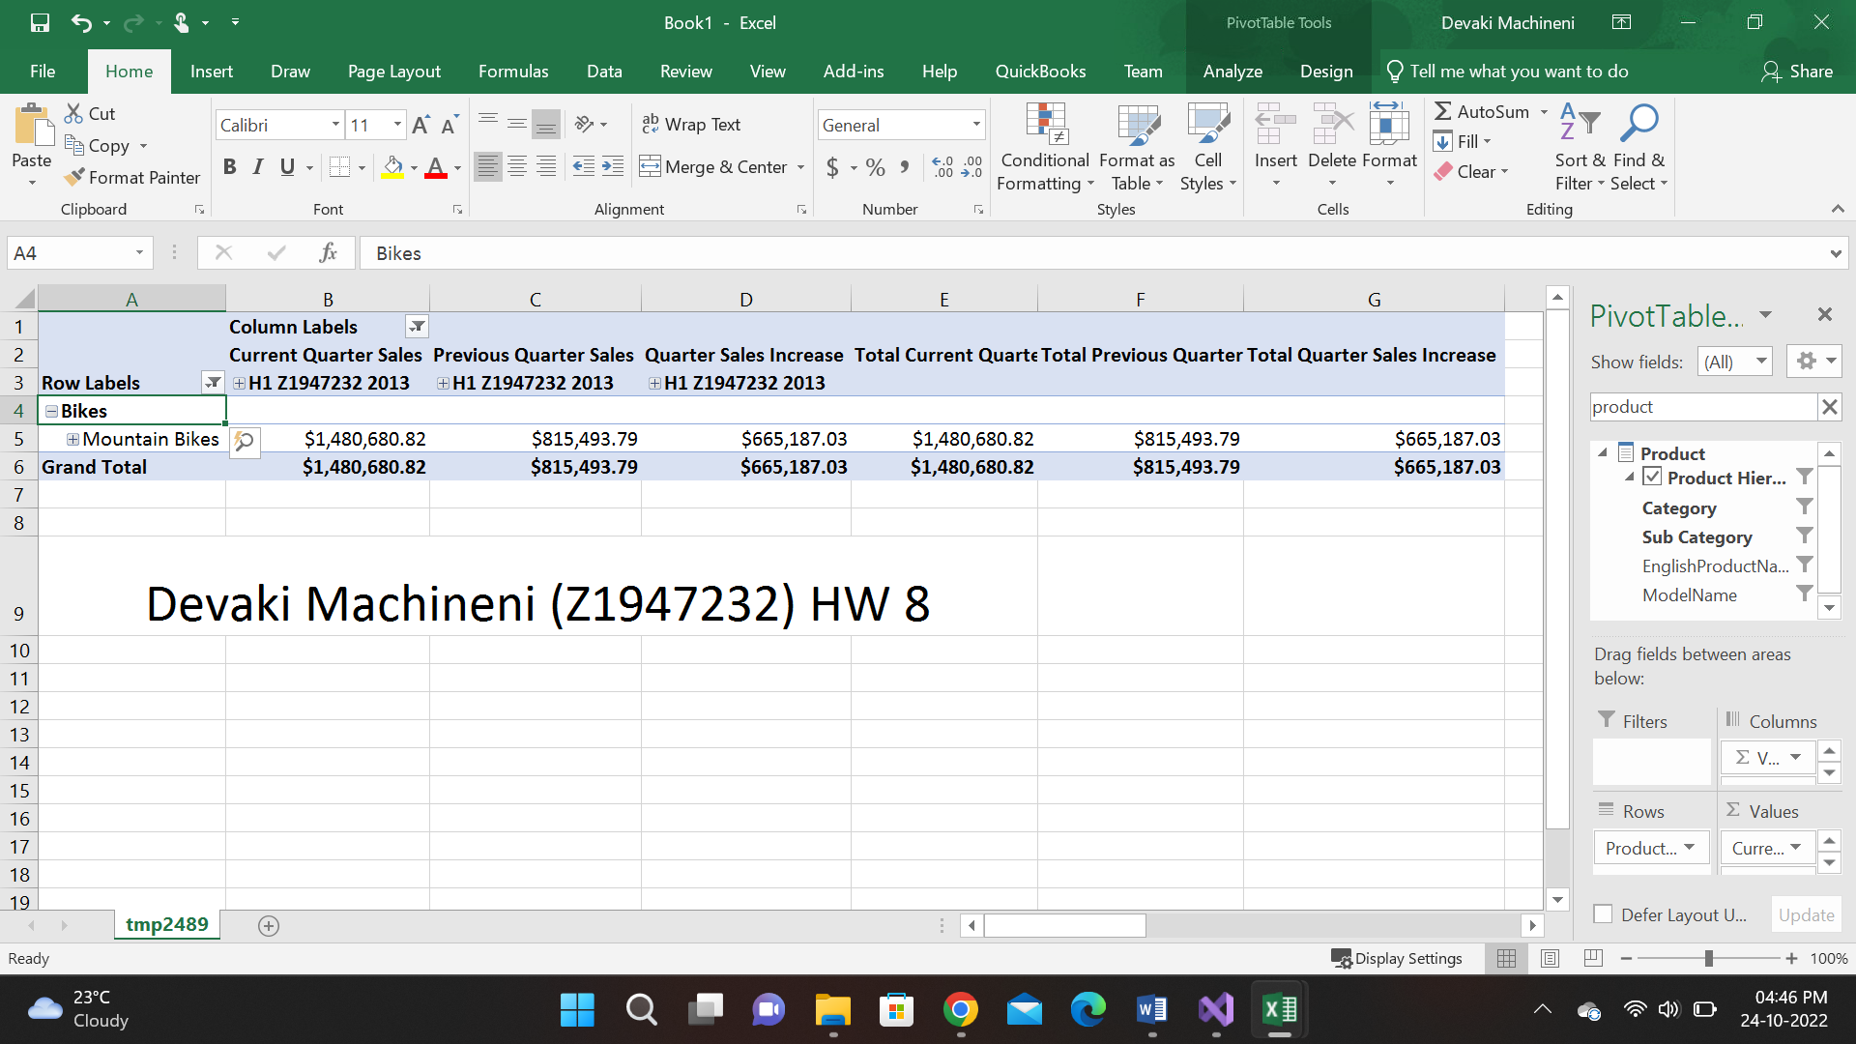

I have inserted Date Hierarchy into rows and in the filters, I have inserted Product hierarchy because I only need the values of the mountain bike. And selected the mountain bike option. I have inserted Current quarter sales, Previous quarter sales, and Quarter sales increase into the values section. Further, I have selected the H1 2013 year for the results.